Software Requirements Specification
for
Vaccineto
Version 1.0 approved
Prepared by Omar Ahmed & Mazen Mohamed
1/12/2022
Table of Contents
Table of Contents ii
1. Introduction 1
1.1 Purpose 1
1.2 Intended Audience and Reading Suggestions 1
1.3 Product Scope 1
2. Overall Description 2
2.1 Product Perspective 2
2.2 Operating Environment 2
2.4 Assumptions and Dependencies 3
3. External Interface Requirements 3
3.1 User Interfaces 3
4. System Features 4
4.1 System Feature 1 4
4.2 System Feature 2 (and so on) 4
5. Other Nonfunctional Requirements 4
5.1 Performance Requirements 4
5.2 Safety Requirements 5
5.3 Security Requirements 5
5.4 Software Quality Attributes 5

Introduction

Purpose
Simplifying vaccination process by automating reservation phase to reduce overcrowding of the medical facilities.

Intended Audience and Reading Suggestions
This document will help developers, testers and project managers to handle the development process to ease understanding what each party is responsible for to produce the best version of the final product and for Market Staff, Users and Testers to understand the system features.
Suggestions for reading sequence:
Marketing Staff: read system features section
Users: read non-function requirements section
Testers: read system features and non-functional requirements sections

Product Scope
The system allows the users to reserve the vaccine and the vaccination centers to deal with the reservations on the other side to ease the process on all people concerned with the reservation process.

Overall Description

Product Perspective
This product is a new, self-contained product which is built due to the new pandemic (Covid-19) requirements and its purpose is to automate reservation phase.

Operating Environment
The Software requires the following to operate (minimum):
-Operating System: Windows 10 or later
-Disk Space: 5.32 GB
-Processor: Intel Core i5 6600k or AMD Ryzen 5 1600
-Memory: 6 GB RAM

Design and Implementation Constraints
One possible constraint is that the vaccination must be authorized by the government laws and policies by testing samples of different types of vaccines under different circumstances to make sure that the vaccine is approved for human use and that the system does not violate the rules in any way, shape or form.

User Documentation
The program has three point of views:
- First, if you choose to login as a user, you will enter your information in the registration form, after that you will be able to view the vaccination centers available and reserve your vaccine dose, after you reserve you will receive your reservation number which you will use when visiting the medical facility to receive your dose.
You will only be able to reserve the second dose after you have received the first dose with 14 days, after you take your second dose you will receive a certificate confirming that you finished the vaccination process.
- Secondly, if you choose to login as an admin, you will enter your information in the registration form, after that you will be able to view, add and update vaccination centers, you will also be able to add vaccine and cities.
- The third option is to login as a vaccination center, you will be able to view patients by their reservation number, and you will be able to confirm the dose requests of the users.

Assumptions and Dependencies
The cost of the external machines required to approve the vaccines might be high and not available to the government in which the website would be used.
Not all the vaccines are available in all medical facilities which the system depends on.

External Interface Requirements

User Interfaces
- First, the registration form will appear

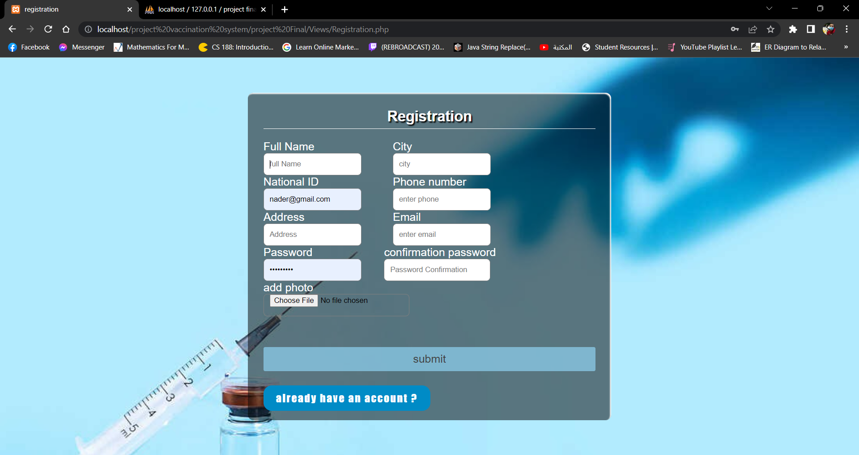
- Then the login page appears
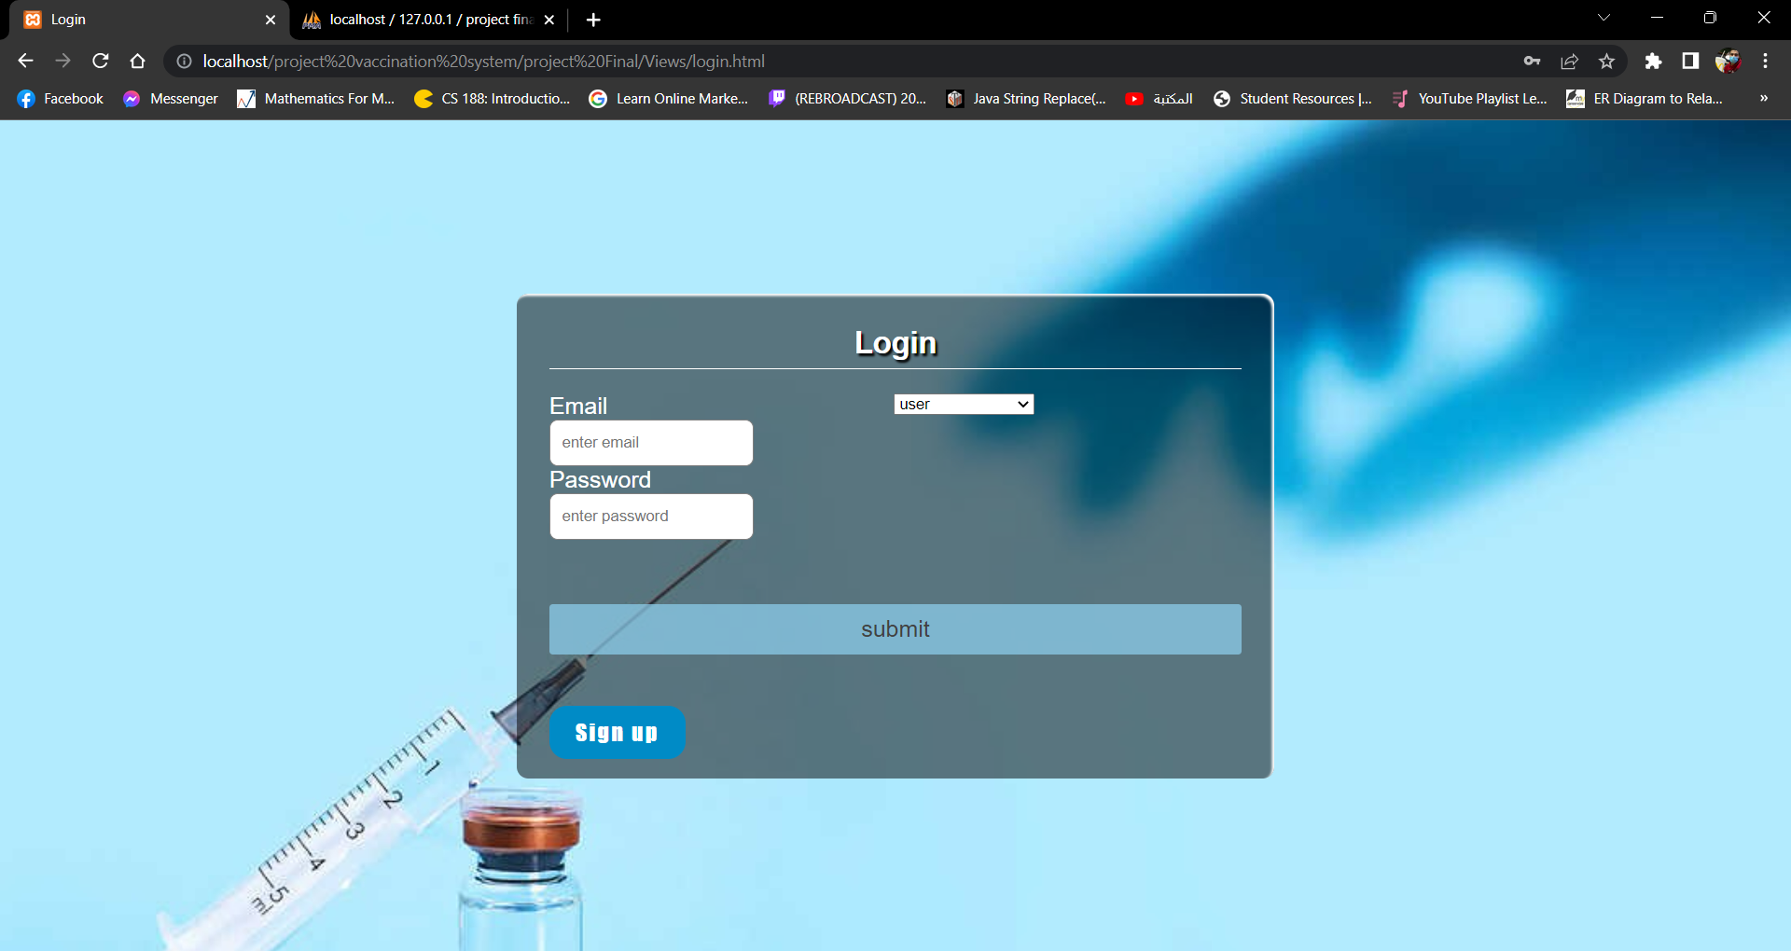

- You will be able to choose whether to login as a user, admin or a vaccination center
- If you login as a user you will be able to view the vaccination centers available

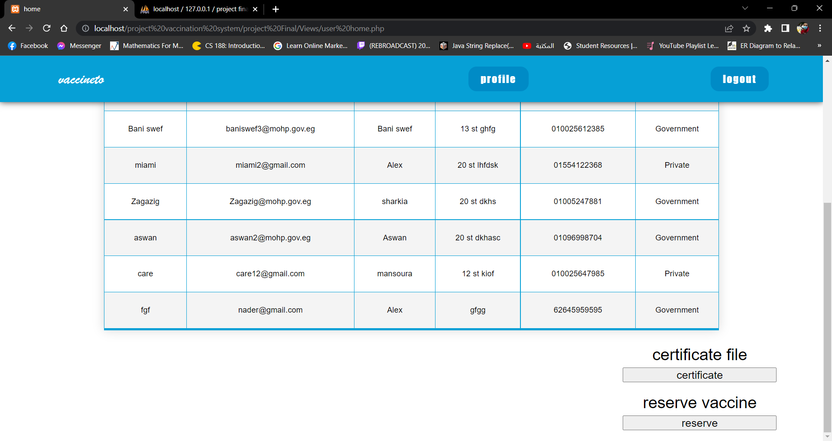
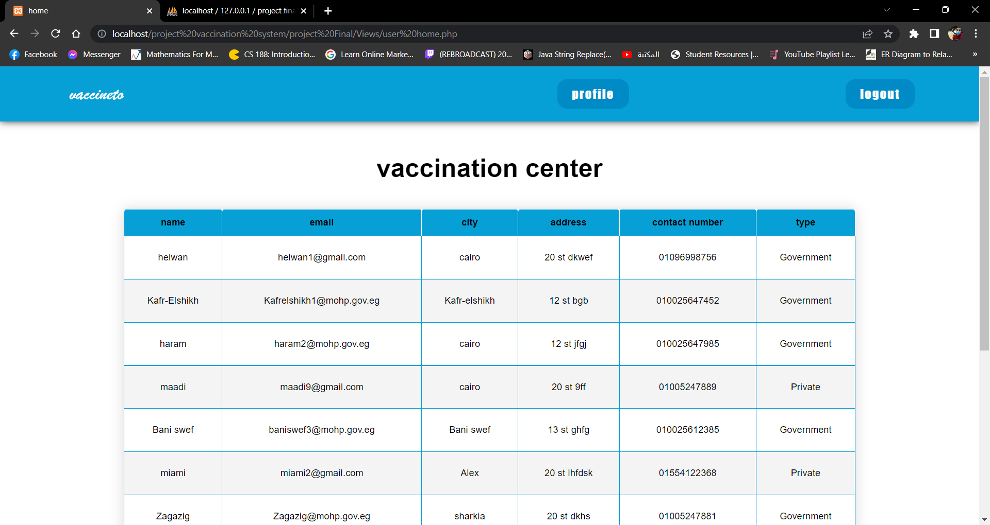

- You will be able to reserve your vaccination through this form
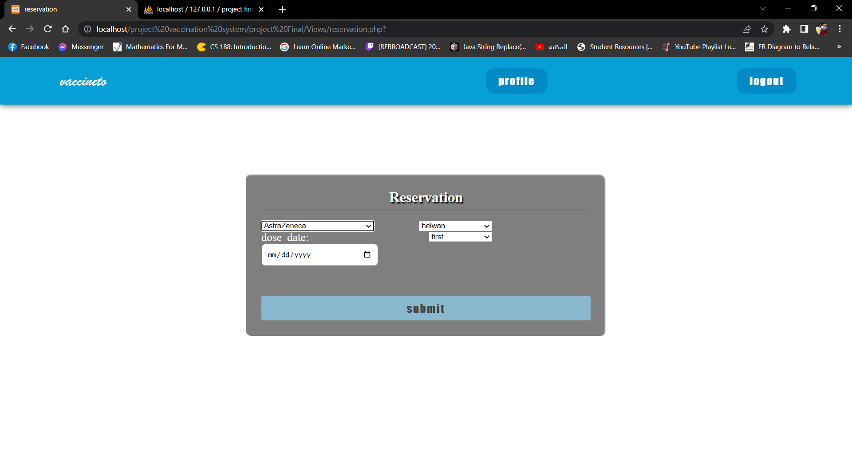

- You can view your profile by clicking on the profile button
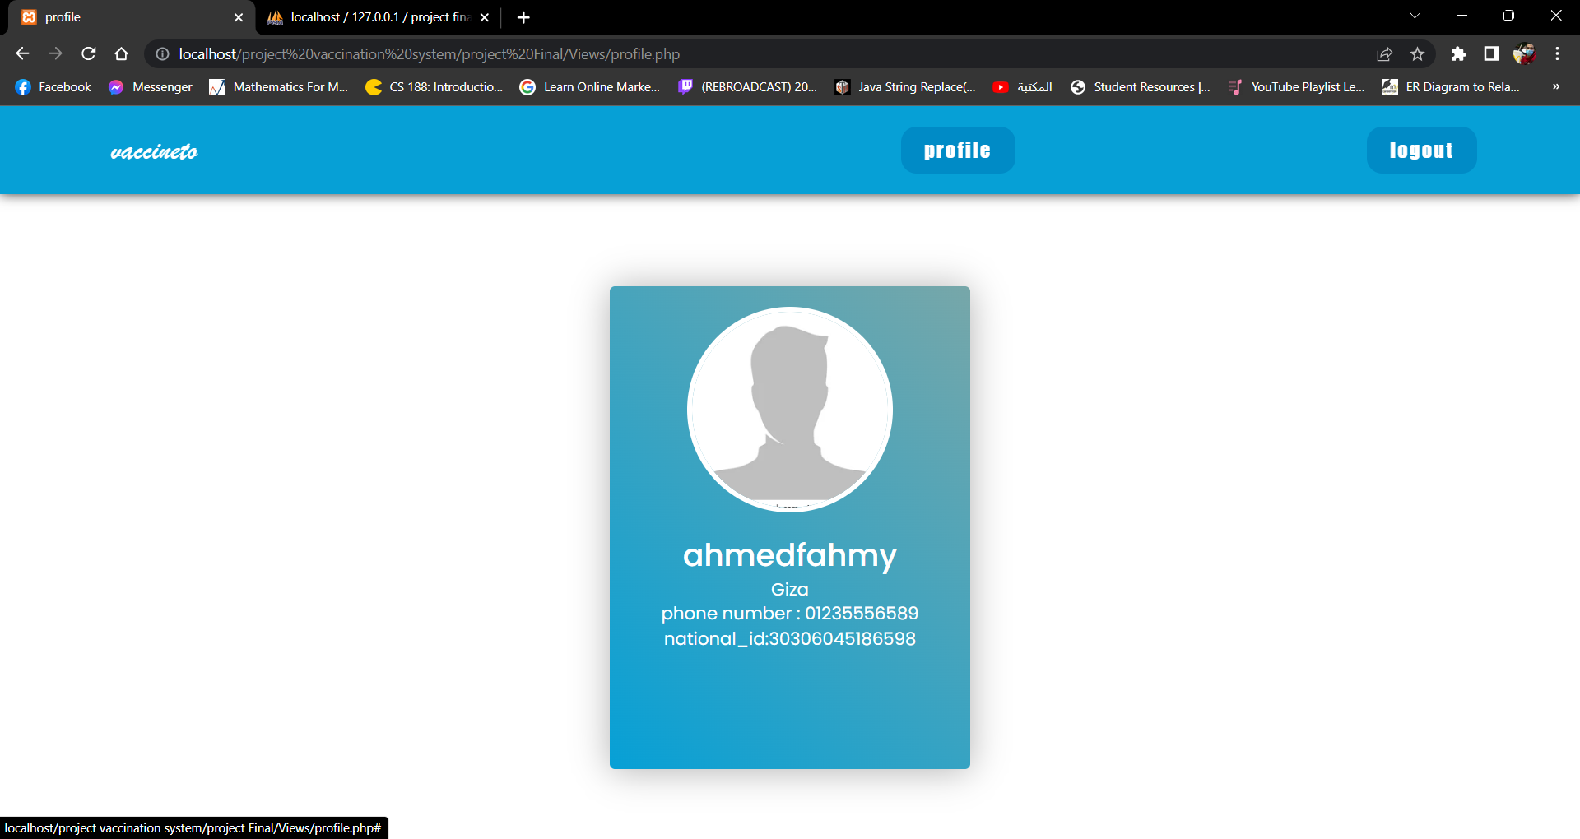

- If you login as an admin, you will be able to view the vaccination centers and search with city
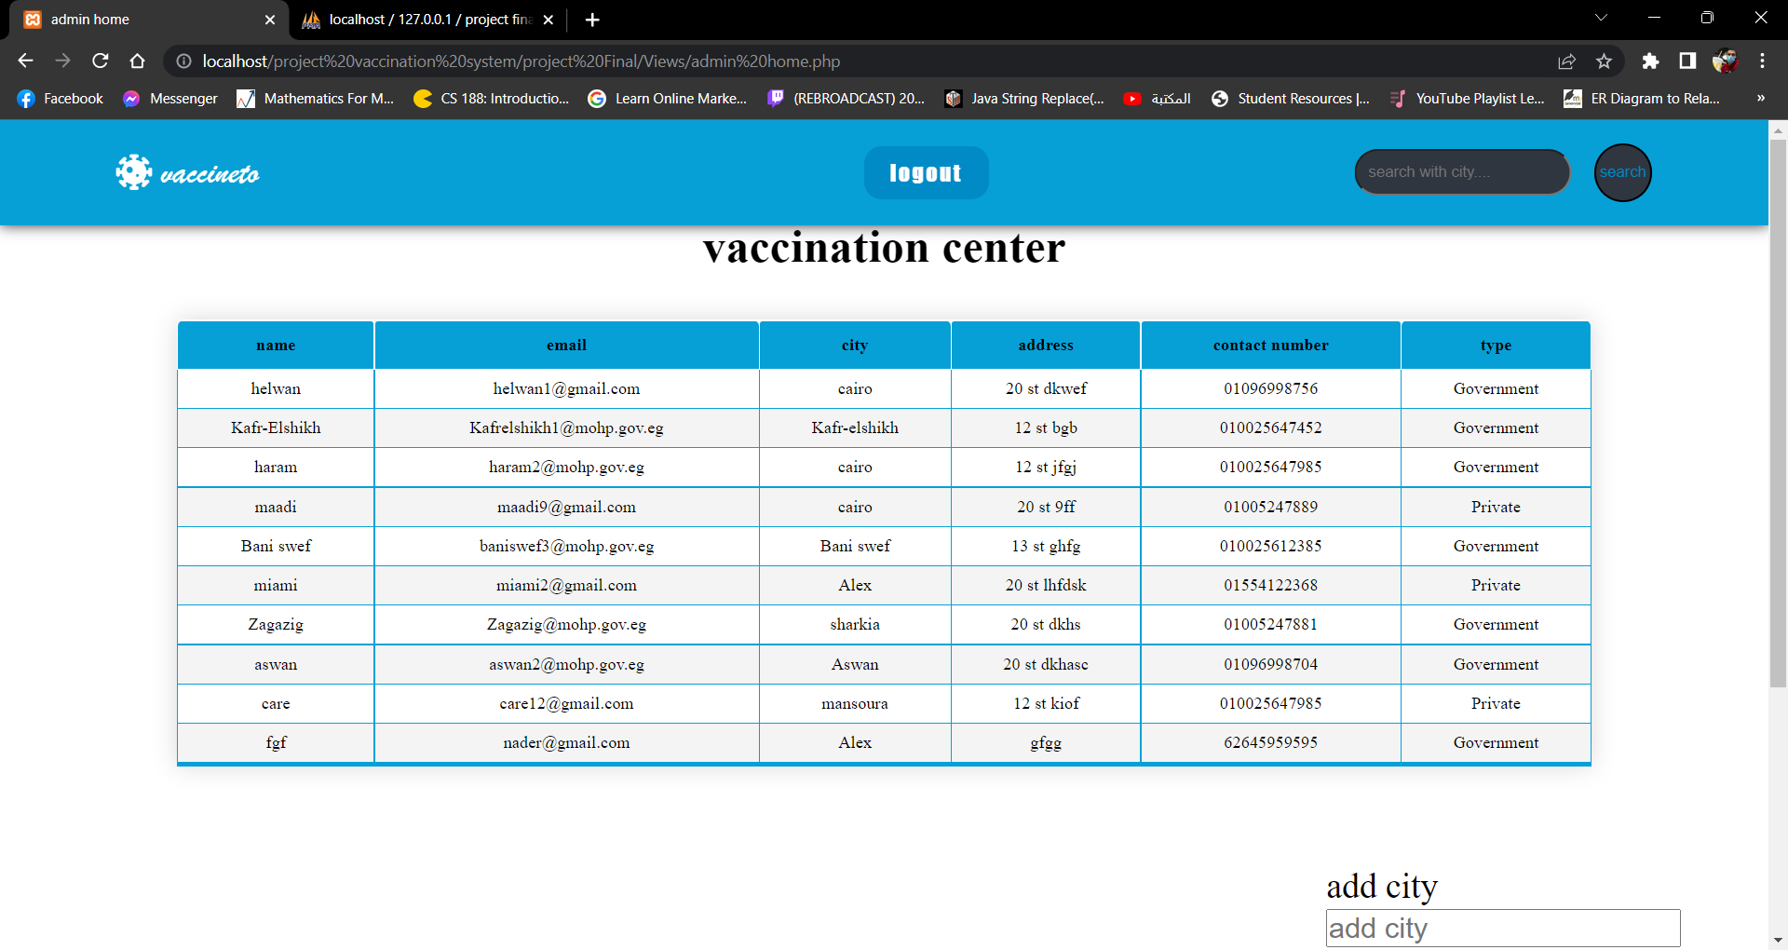

- You will also be able to add city, vaccination center, vaccine and view users by clicking on any button of these
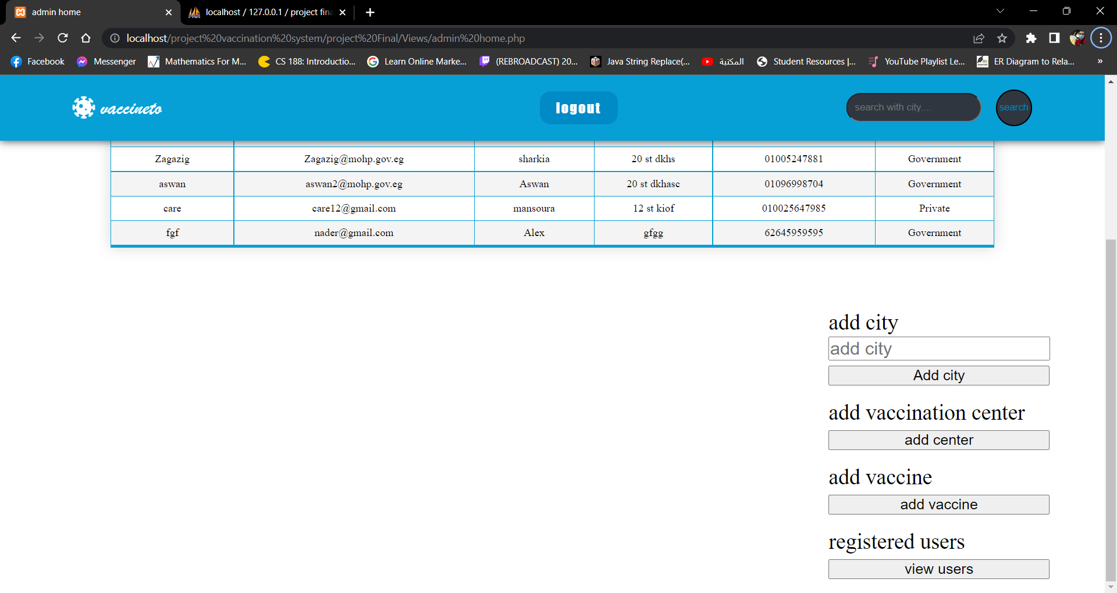
- If you want to add a vaccination center, you will have to fill the following form
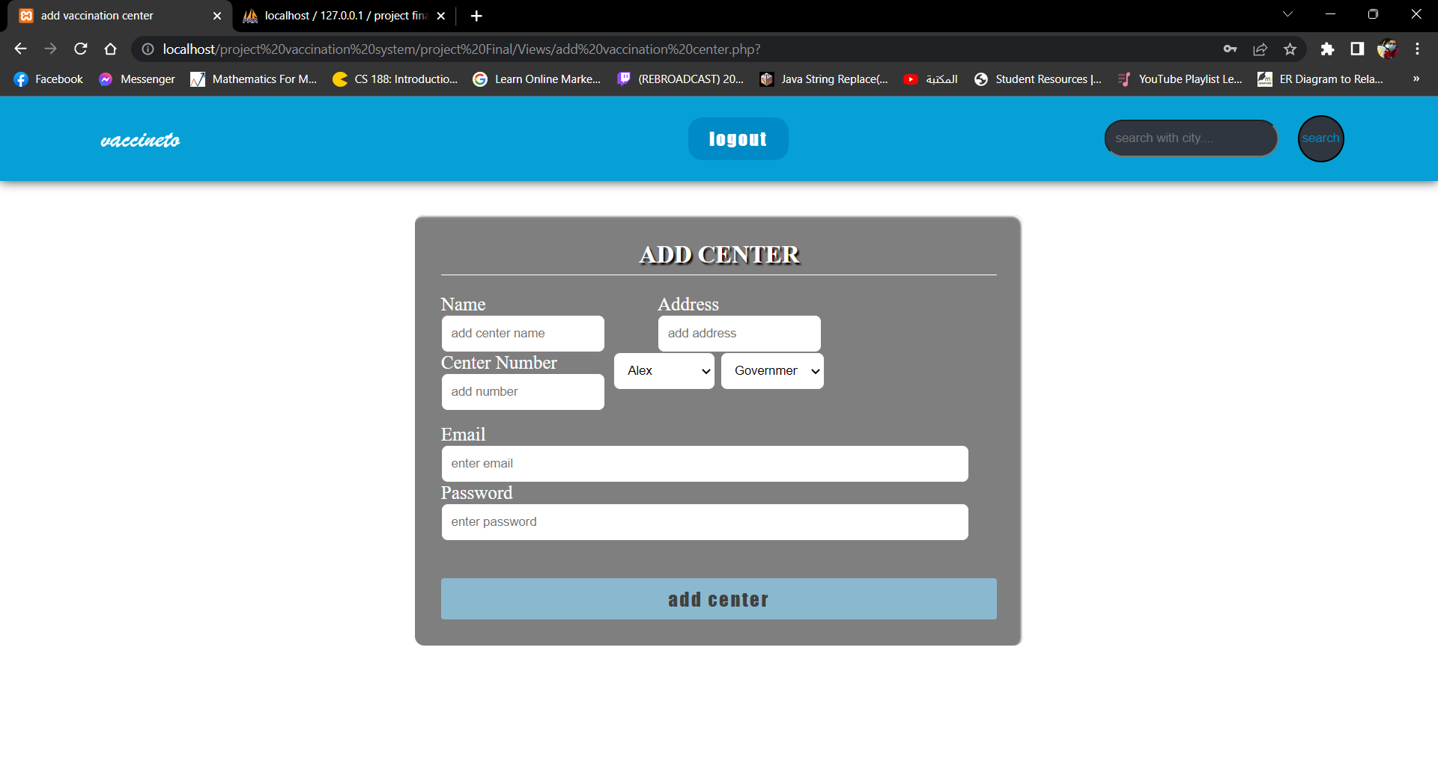

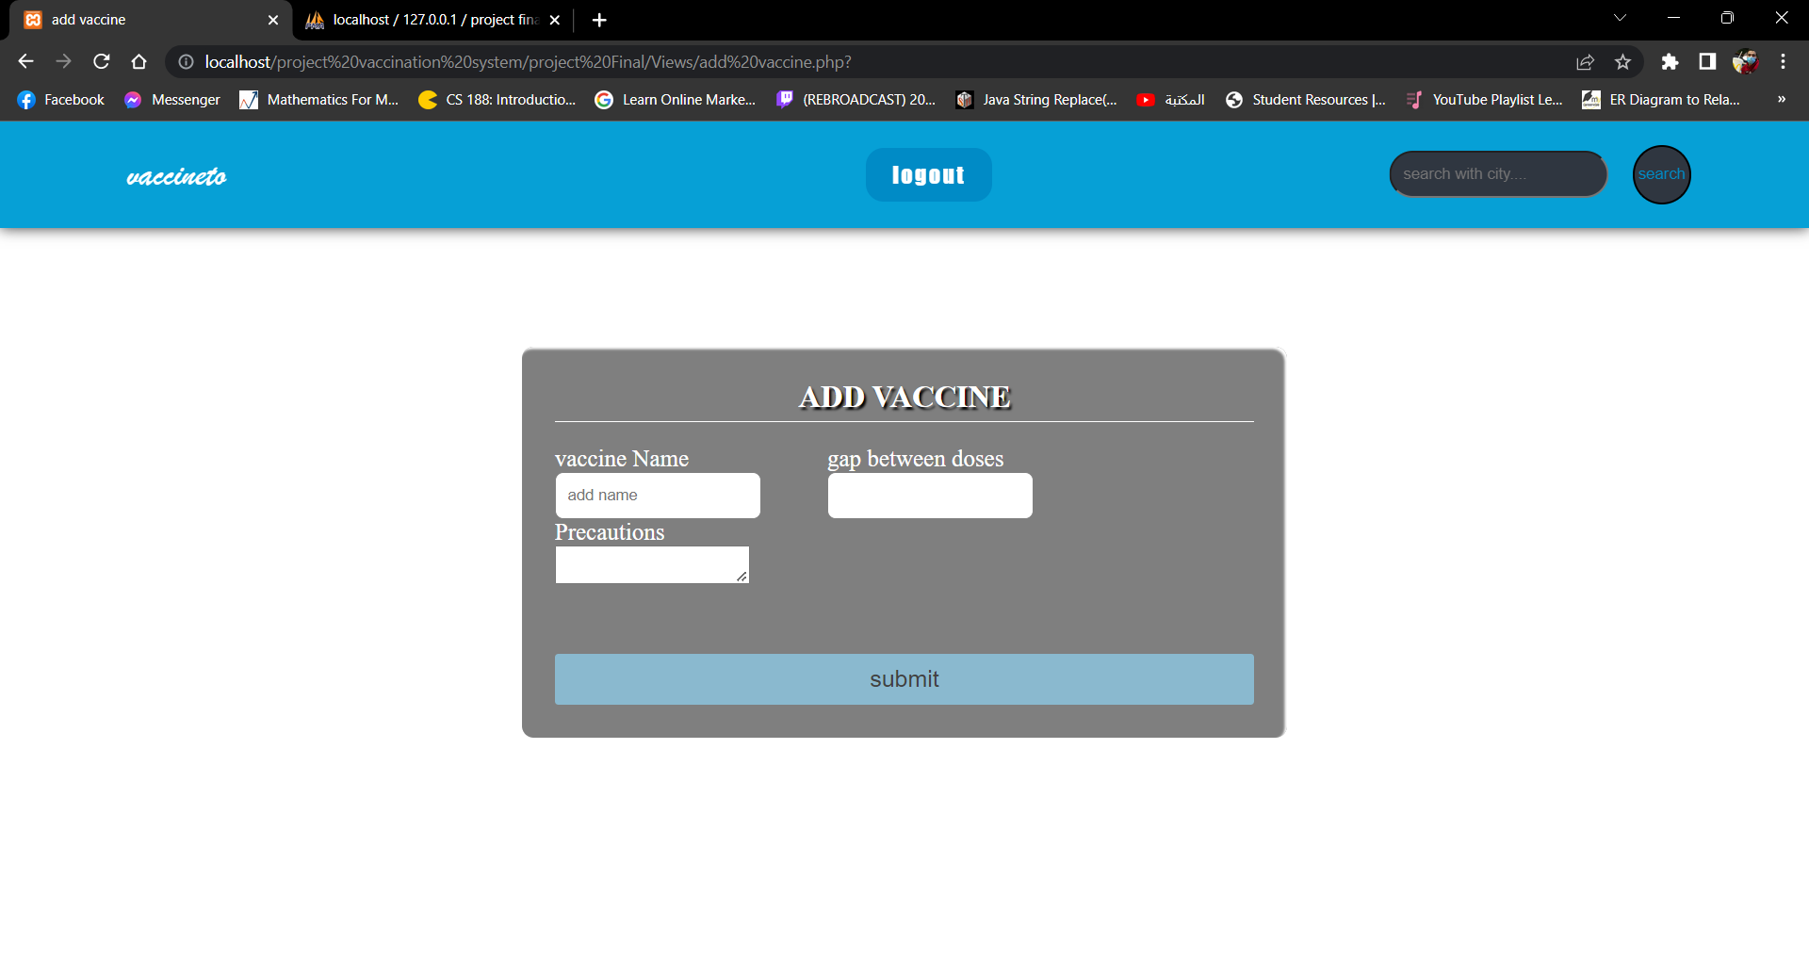
- If you want to add a vaccine, you will have to fill the following form

- You can view all registered users by clicking on the view users button
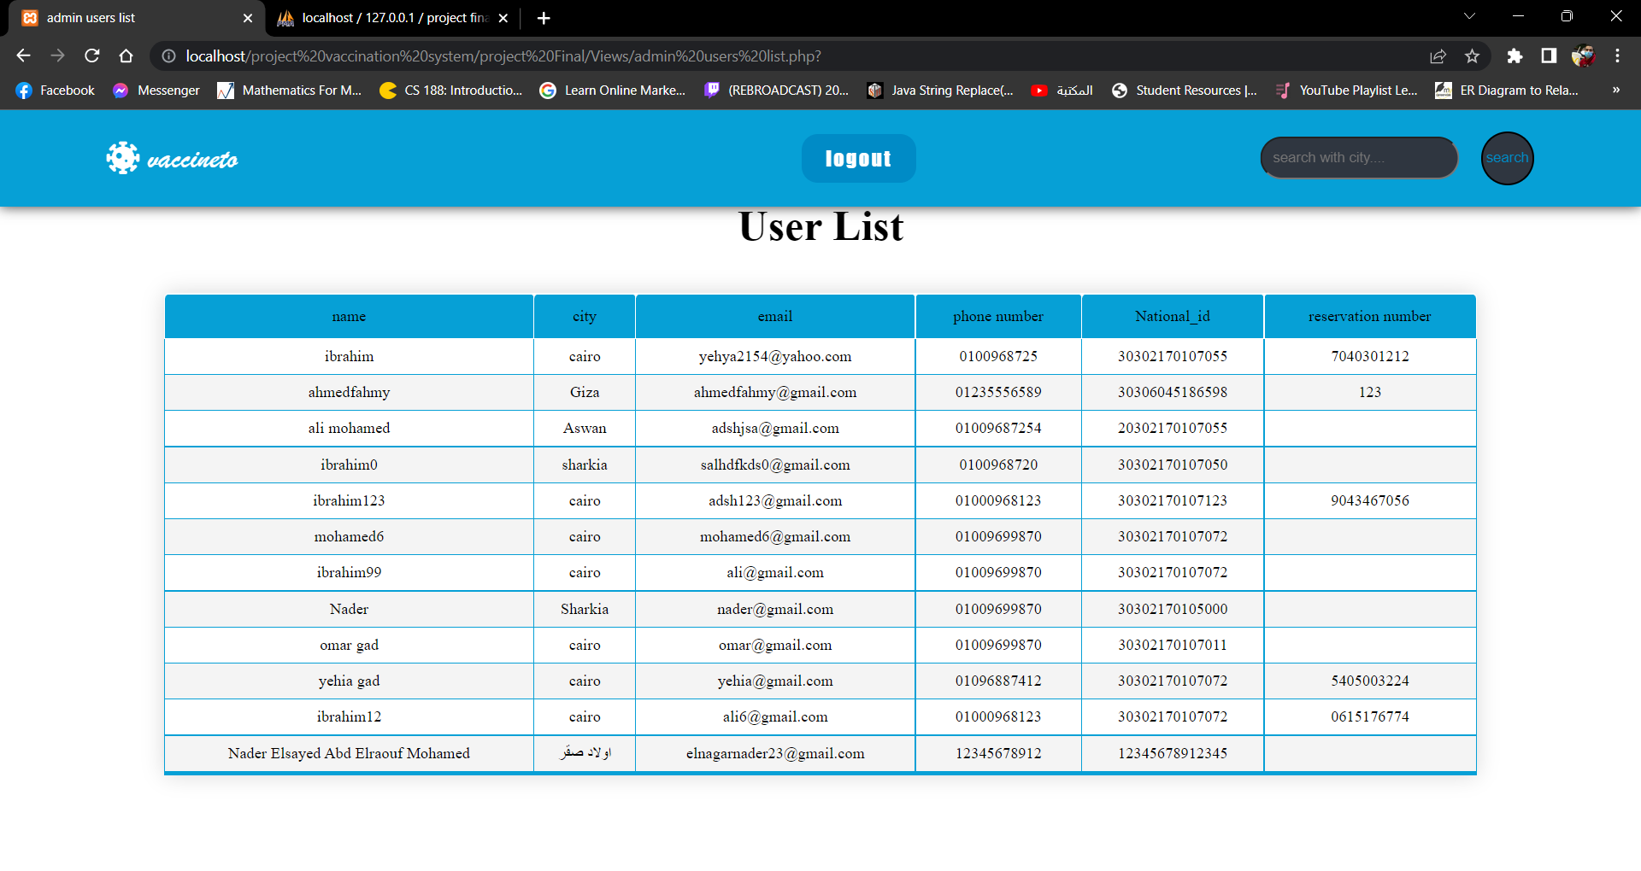

- If you search by city, the results will appear
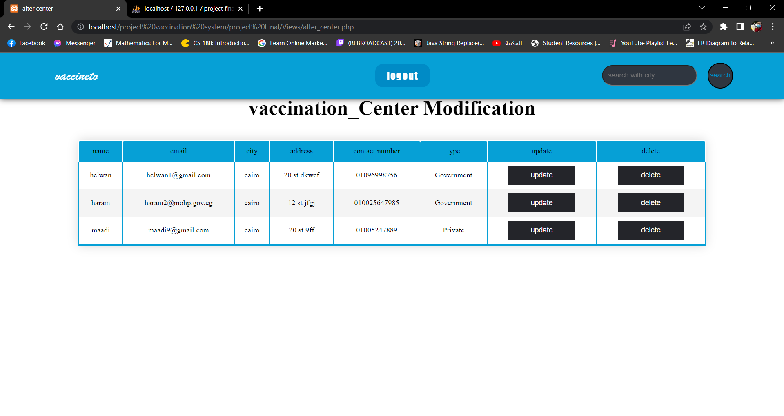

- You can update the center by clicking on the center button in front of it, then choose the data that you want to change, then enter the new value
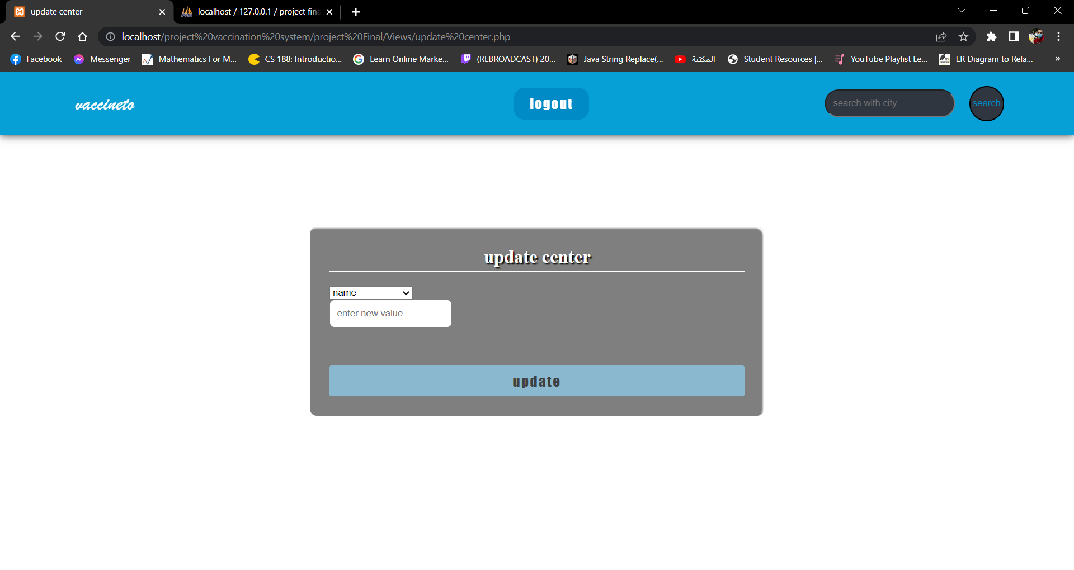

- If you login as a vaccination center, you will be able to confirm the patients reservations and search for patients by their reservation number
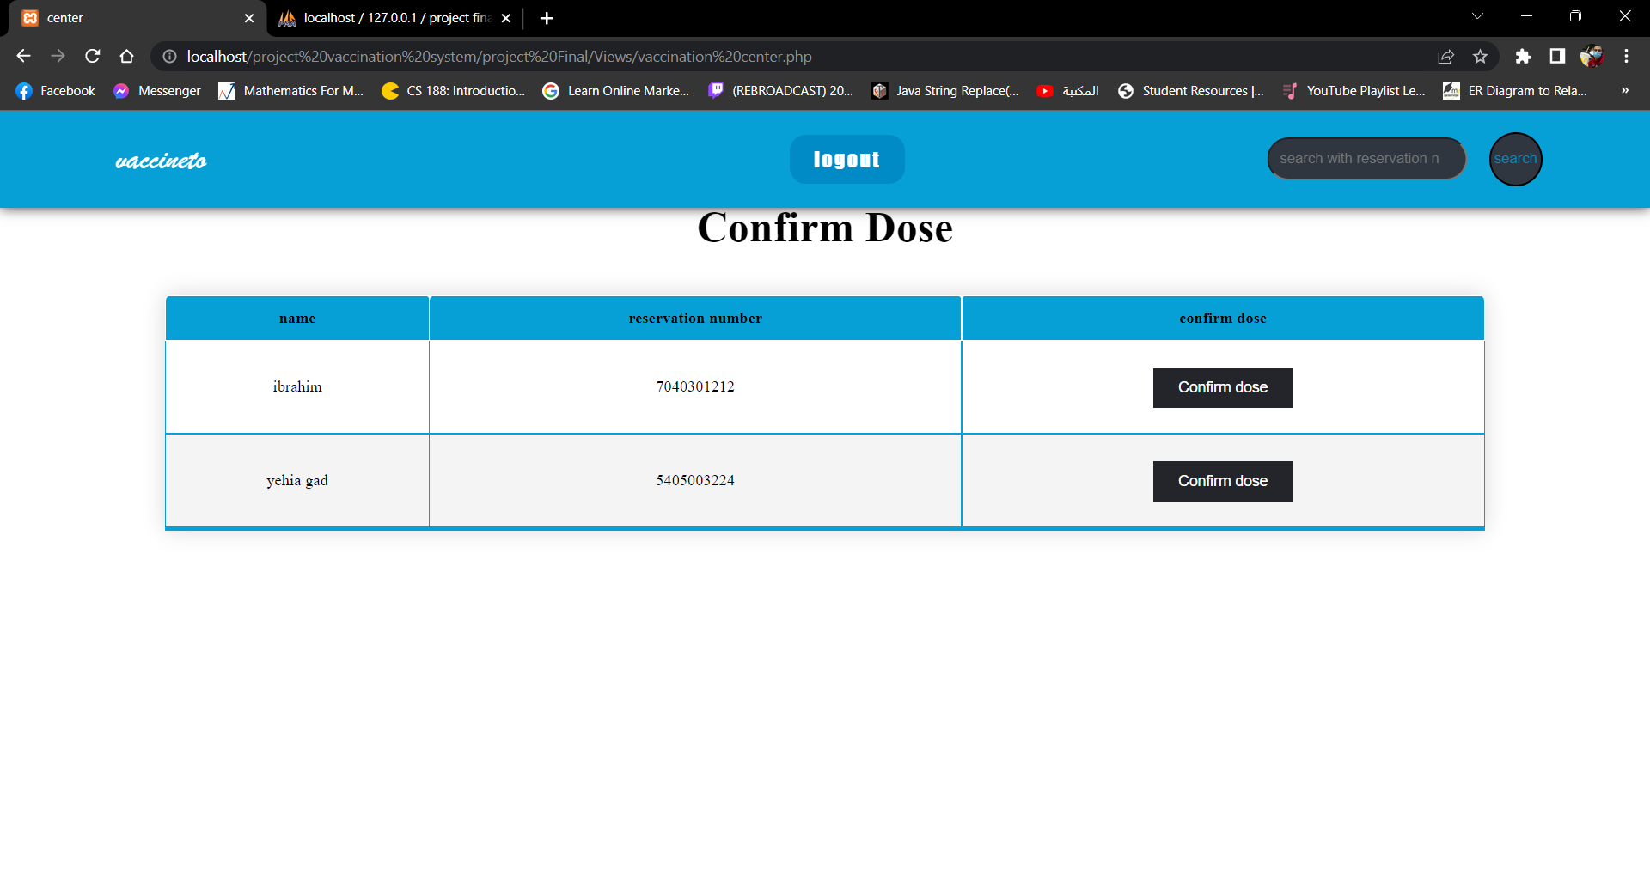

Hardware Interfaces
Can operate on different devices like mobile phones, laptops and desktops only if it can run a browser.

Software Interfaces
It can run on different operating systems like android, windows or linux.

System Features
- According to your role you will be able to do any of the following features:
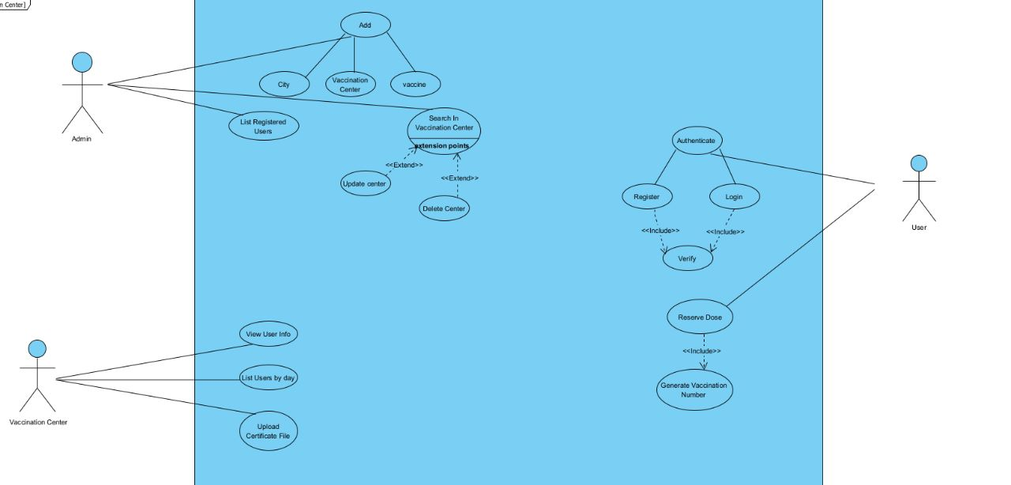

Other Nonfunctional Requirements

Performance Requirements
<If there are performance requirements for the product under various circumstances, state them here and explain their rationale, to help the developers understand the intent and make suitable design choices. Specify the timing relationships for real time systems. Make such requirements as

Safety Requirements
If user interrupts the submission process or closes the window during saving or processing data which may result in data loss or leak.

Security Requirements
Do not share your password with another party, it is better to not use a common or weak password that has a pattern that can be easily revealed. This might cause hacking your info.

Software Quality Attributes
This software is maintainable i.e. bugs can be fixed easily when found, it also can run on different types of operating systems and different device properties. Moreover, it is portable and adaptable which can be used by various organizations that provide the vaccines.

